Api Integration
Workshop #01
Flutter Developer Bootcamp

Purpose
This code demonstrates how to integrate API calls into a Flutter application and handle asynchronous operations to fetch and display data.

Problem

In this workshop, we're diving into Flutter application that seamlessly integrates with a REST API. The code revolves around a StatefulWidget named HomePage, complemented by its State class _HomePageState. It orchestrates the fetching and display of data retrieved from a specified endpoint. Key components include _data for storing fetched content and _isLoading for managing loading states. Through the fetchData() method, the app communicates with the API, updating the UI accordingly. Finally, the UI presents a Scaffold widget featuring an AppBar and a dynamic body that switches between a loading indicator and a ListView populated with fetched data.

How to Solve
1. Checkout the workshop from Git Repo:
git clone -b <user-branch> <repo-URL>
2. Open the root folder inside VS Code
3. To build the app click the run option in the main method { }
4. You want to integrate the api into the code .
5. https://jsonplaceholder.typicode.com/posts

You Will Achieve

This Flutter code integrates with an API to fetch data and display it in a ListView. Let's break down what it achieves:

- Fetch Data: It makes an HTTP GET request to https://jsonplaceholder.typicode.com/posts to retrieve a list of posts.

- Display Data: Once the data is fetched successfully, it populates a ListView with ListTile widgets, displaying the title and body of each post.

- Loading Indicator: While the data is being fetched, a CircularProgressIndicator is displayed at the centre of the screen.

- Error Handling: If the HTTP request fails (i.e., if the status code is not 200), it throws an exception with the message 'Failed to load data'.

Overall, this code provides a basic implementation of fetching and displaying data from an API in a Flutter app. It demonstrates important concepts such as asynchronous programming with Futures, state management with StatefulWidget, and UI updates with setState().

Screenshots

Before implementation (without API)
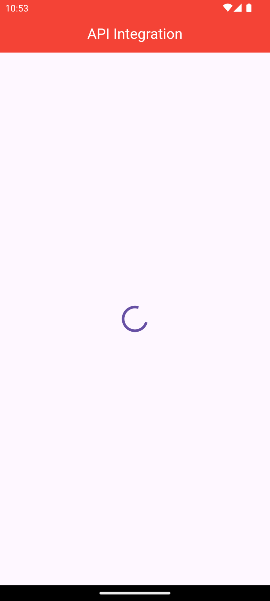

After implementation (With API)
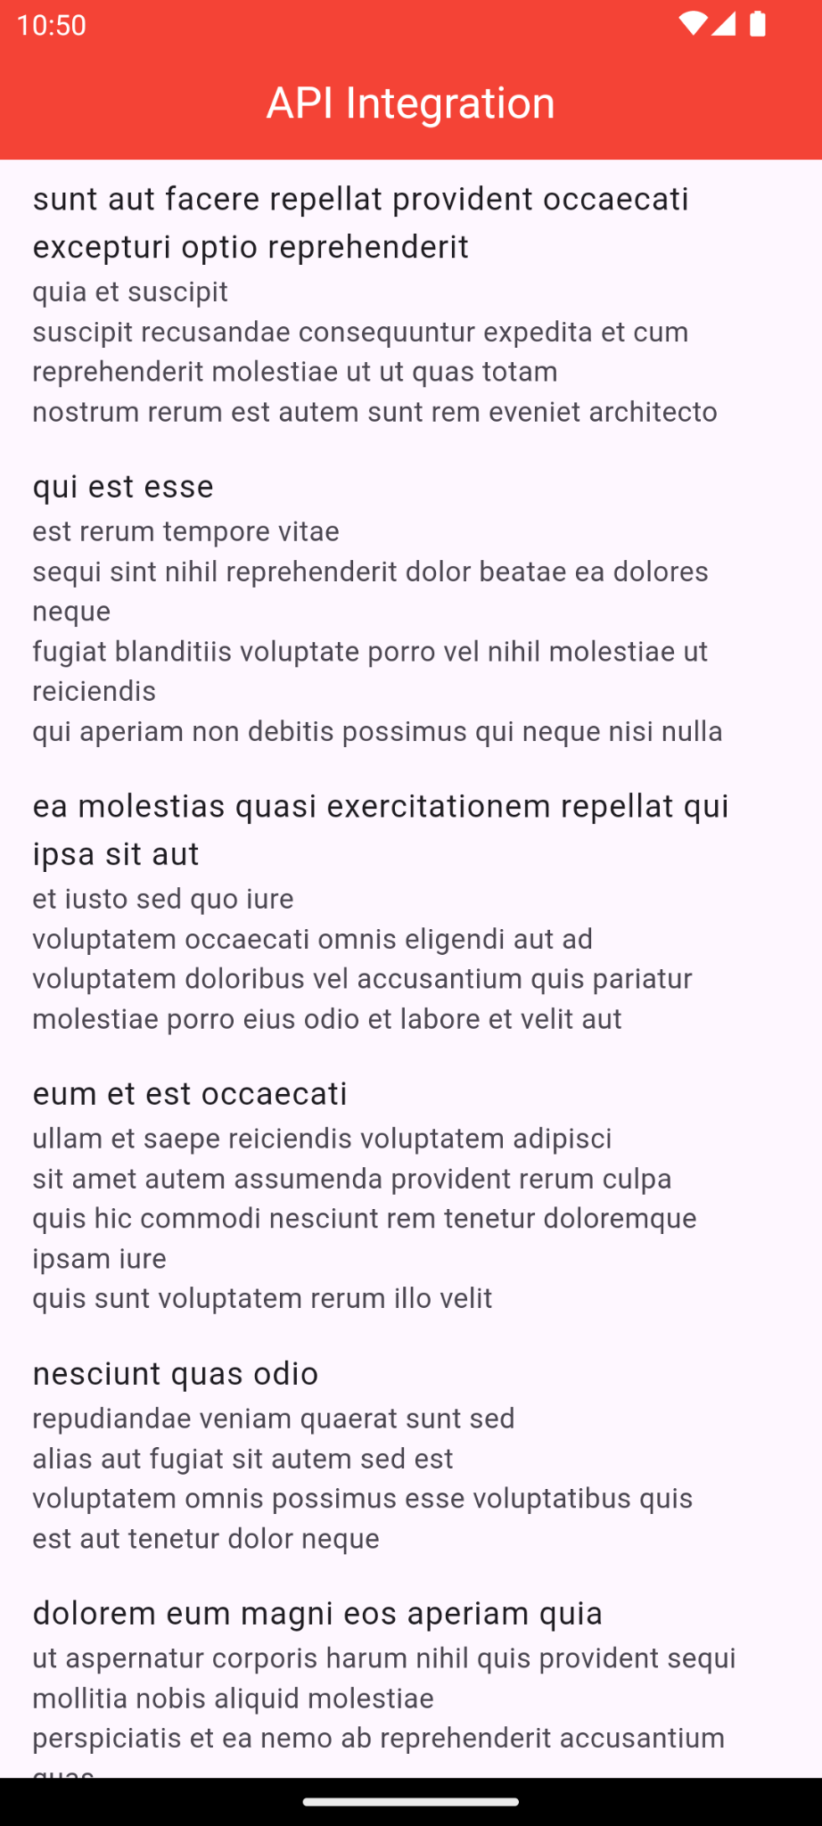

How to submit your workshop
Push your project back to the same git branch using command:
<command name>

Happy Coding!

